

­­­

OOP Assignment 2

Name: Syed Muhammad Raza Ali

Enrolment: 02-134231-028

Course: Object Oriented Programming

Faculty: Miss Sameena Javaid

**QUESTION NO. 2**

**(CLO2, PLO2, C3)**

**Develop** an object-oriented programming case study involving a Library Management System. In this case study, we'll apply the concepts of Association, Aggregation, Composition, and Inheritance to model the relationships between various entities in the library system.

Entities in the Library Management System:

1. Library
   * Attributes: Name, Address
   * Relationships: Aggregates Books, Aggregates Librarians
2. Book
   * Attributes: Title, Author, ISBN, Genre
   * Relationships: Associated with Library
3. Librarian
   * Attributes: Name, Employee ID
   * Relationships: Associated with Library
4. Member
   * Attributes: Name, Member ID
   * Relationships: Borrowed Books (Association)

Develop UML and a Java program and the problem must be implemented by applying the concepts of Association, Aggregation, Composition, and Inheritance.

**\*\*\*\*\*\*\*\*\*\*\*\*\*\*\*\*\*\*\*\*\*\*\*\*\*\***

UML Diagram

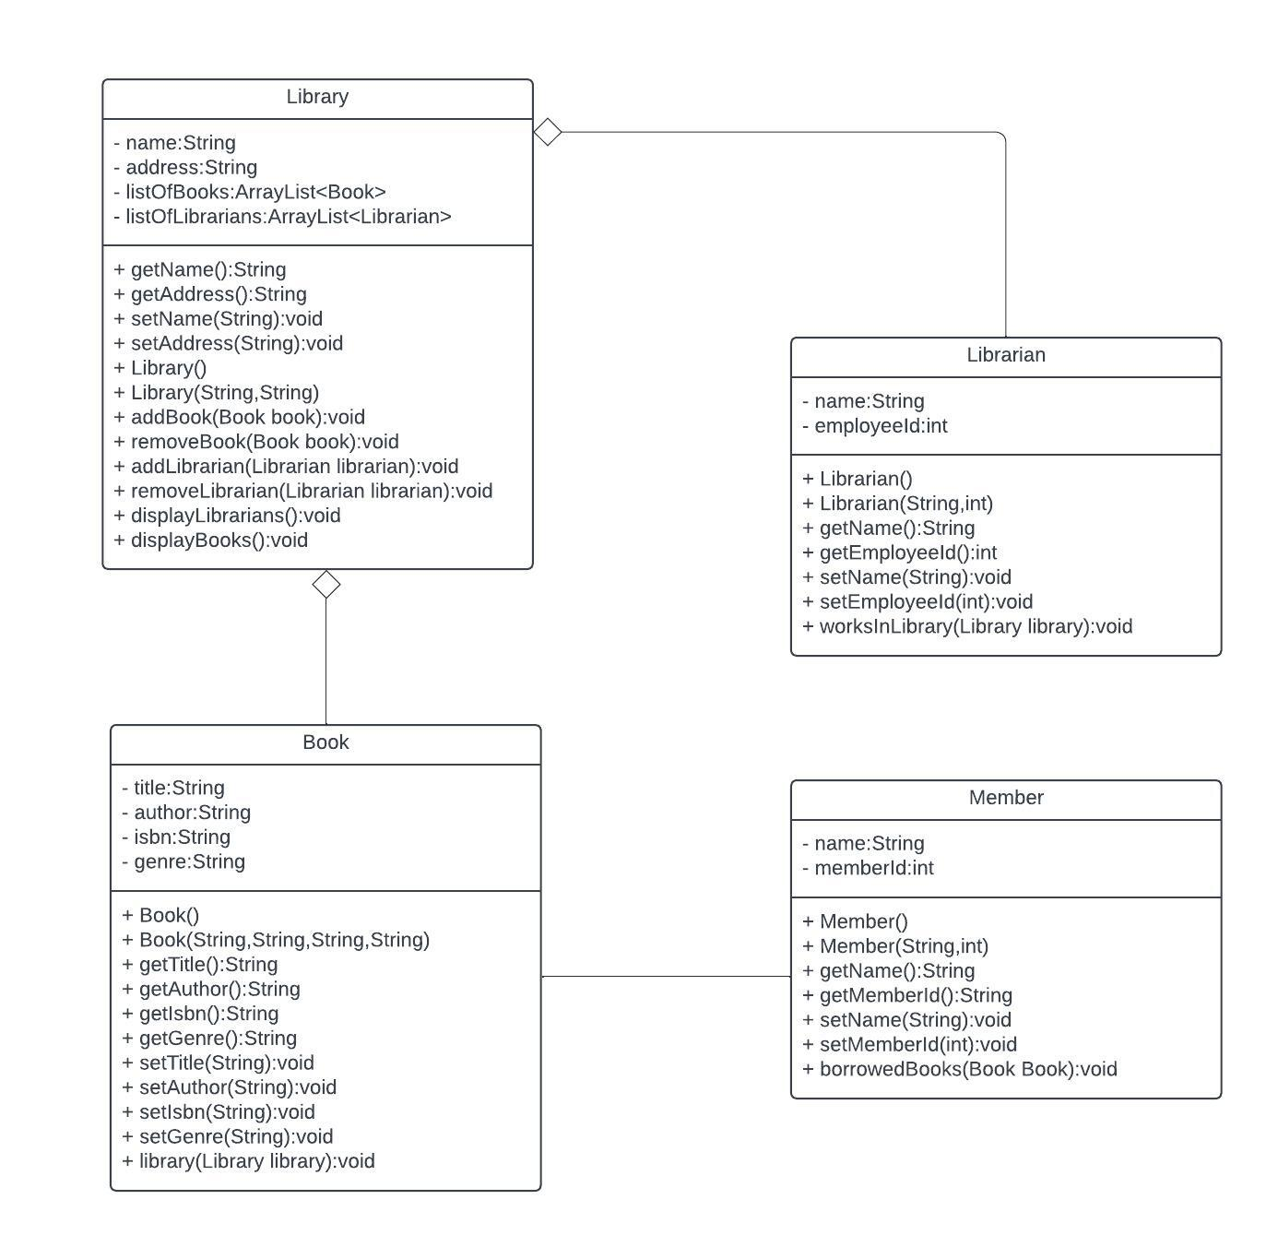

Code:

Library Class

import java.util.ArrayList;

public class Library{

//attributes

private String name,address;

private ArrayList<Book> listOfBooks = new ArrayList<Book>();

private ArrayList<Librarian> listOfLibrarians = new ArrayList<Librarian>();

//Constructor

public Library() {

}

public Library(String name, String address) {

this.name = name;

this.address = address;

}

//getters

public String getName() {

return name;

}

public String getAddress() {

return address;

}

//setters

public void setName(String name) {

this.name = name;

}

public void setAddress(String address) {

this.address = address;

}

//methods

public void addBook(Book book){

listOfBooks.add(book);

}

public void removeBook(Book book){

listOfBooks.remove(book);

}

public void addLibrarian(Librarian librarian){

listOfLibrarians.add(librarian);

}

public void removeLibrarian(Librarian librarian){

listOfLibrarians.remove(librarian);

}

public void displayLibrarians(){

System.out.println("======== Librarians ========");

for(int i=0;i<listOfLibrarians.size();i++){

System.out.println("* Librarian : "+(i+1)+"\n"

+ "Librarian name : "+listOfLibrarians.get(i).getName()+"\n"

+ "Librarian Id : "+listOfLibrarians.get(i).getEmployeeId());

}

}

public void displayBooks(){

System.out.println("======== Books ========");

for(int i = 0;i<listOfBooks.size();i++){

System.out.println("* Book "+(i+1)+"\n Book title : "+listOfBooks.get(i).getTitle()+

"\n Book author : "+listOfBooks.get(i).getAuthor()+"\n"

+ "Book ISBN : "+listOfBooks.get(i).getIsbn()+"\n"

+"Book Genre : "+listOfBooks.get(i).getGenre());

}

}

}

Book Class

package com.mycompany.librarymanagementsystem;

public class Book{

//attributes

private String title,author,isbn,genre;

//constructors

public Book() {

}

public Book(String title, String author, String isbn, String genre) {

this.title = title;

this.author = author;

this.isbn = isbn;

this.genre = genre;

}

//getters

public String getAuthor() {

return author;

}

public String getGenre() {

return genre;

}

public String getIsbn() {

return isbn;

}

public String getTitle() {

return title;

}

//setters

public void setAuthor(String author) {

this.author = author;

}

public void setGenre(String genre) {

this.genre = genre;

}

public void setIsbn(String isbn) {

this.isbn = isbn;

}

public void setTitle(String title) {

this.title = title;

}

//methods

public void library(Library library){

System.out.println("This Book is available in Library : "+library.getName());

}

}

Librarian Class:

public class Librarian{

//attributes

private String name;

private int employeeId;

//getters

public String getName() {

return name;

}

public int getEmployeeId() {

return employeeId;

}

//setters

public void setName(String name) {

this.name = name;

}

public void setEmployeeId(int employeeId) {

this.employeeId = employeeId;

}

//Constructor

public Librarian() {

}

public Librarian(String name, int employeeId) {

this.name = name;

this.employeeId = employeeId;

}

//methods

public void worksInLibrary(Library library){

System.out.println(this.getName()+" Works is a Librarian in "+library.getName()+" Library");

}

}

Member Class

public class Member{

private String name;

private int memberId;

//Constructor

public Member() {

}

public Member(String name, int memberId) {

this.name = name;

this.memberId = memberId;

}

//getters

public String getName() {

return name;

}

public int getMemberId() {

return memberId;

}

//setters

public void setName(String name) {

this.name = name;

}

public void setMemberId(int memberId) {

this.memberId = memberId;

}

//methods

public void borrowedBooks(Book book){

System.out.println("======== Borrowed Book ========+ \n Book title : "+book.getTitle()+

"\n Book author : "+book.getAuthor()+"\n"

+ "Book ISBN : "+book.getIsbn()+"\n"

+"Book Genre : "+book.getGenre());

}

}

Application Class

package com.mycompany.librarymanagementsystem;

public class LibraryManagementSystem {

public static void main(String[] args) {

//obj of Library

Library myLibrary = new Library("CT Library","Gulshan-e-Iqbal block 6");

//three obj of books

Book book1 = new Book("It ends with us ","Collen Hoover","13387","Romance");

Book book2 = new Book("Fundamentals of Physics","Halliday Resnick","97349","Science");

Book book3 = new Book("Diary of a Wimpy Kid","Jeff Kinney","29390","young adult fiction");

//four objs of librarians

Librarian librarian1 = new Librarian("Aimen", 1400321);

Librarian librarian2 = new Librarian("Muskan", 1400320);

Librarian librarian3 = new Librarian("Huzaifa", 1200319);

Librarian librarian4 = new Librarian("Raza", 1400318);

//two objs of members

Member member1 = new Member("Hasan", 134571);

Member member2 = new Member("Ali", 133574);

//assigning books

myLibrary.addBook(book1);

myLibrary.addBook(book2);

myLibrary.addBook(book3);

//assigning Libraries

myLibrary.addLibrarian(librarian1);

myLibrary.addLibrarian(librarian2);

myLibrary.addLibrarian(librarian3);

myLibrary.addLibrarian(librarian4);

//printing books and librarians

myLibrary.displayBooks();

myLibrary.displayLibrarians();

//borrowed books

member1.borrowedBooks(book1);

member2.borrowedBooks(book3);

}

}